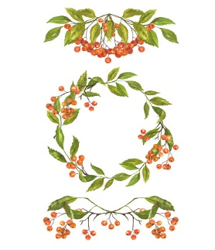
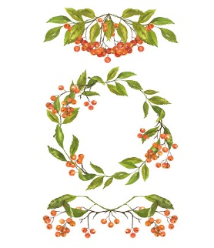
accident
accidentally
actual
actually
address
answer
appear
arrive
believe
bicycle
breathe
breath

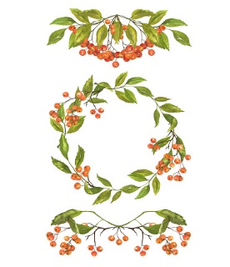
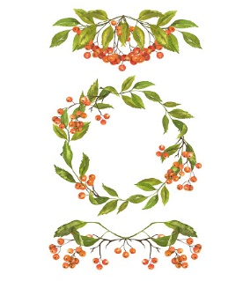
build
busy
business
calendar
caught
centre
century
certain
circle
complete
consider
continue

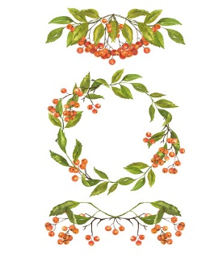
decide
describe
different
difficult
disappear
early
earth
eight
eighth
enough
exercise
experience

experiment
extreme
famous
favourite
February
forward
forwards
fruit
grammar
group
guard
guide

heard
heart
height
history
imagine
increase
important
interest
island
knowledge
learn
length

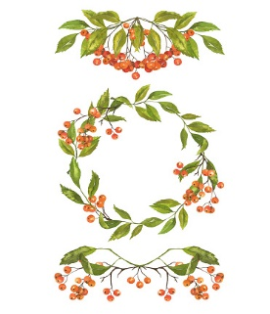
library
material
medicine
mention
minute
natural
naughty
notice
occasion
occasionally
often
opposite

ordinary
particular
peculiar
perhaps
popular
position
possess
possession
possible
potatoes
pressure
probably

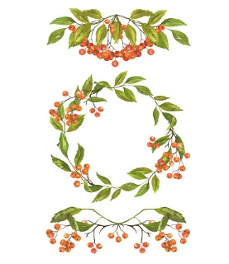
promise
purpose
quarter
question
recent
regular
reign
remember
sentence
separate
special
straight

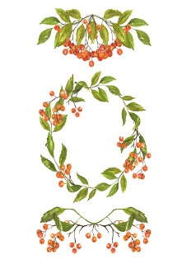
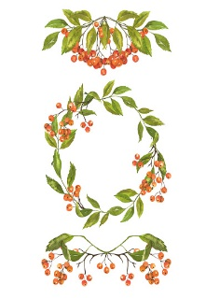
strange
strength
suppose
surprise
therefore
though
although
thought
through
various
weight
woman
women

