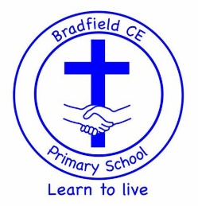
Bradfield CE Primary School Statutory Data 2024

Foundation Stage Profile (End of Reception)
This data shows the % of children who met the required standard (Good Level of
Development – GLD) by the end of Early Years in all the prime areas (Communication and
Language; Personal, Social and Emotional Development and Physical Development) and Literacy and Mathematics. It is a measure of attainment, not progress. These percentages change year on year according to the cohort of children.

Good Level of Development | School | National | Local Authority
2024 | 78% | 67% | 66%
2023 | 73% | 67% | 66%
2022 | 72% | 65% | 65%

Phonics (End of Y1)
This national test is administered in June. It tests the phonic knowledge of children, their ability to decode and read words, not their understanding. Children who do not reach the required pass mark are re-tested at the end of Year 2.

Phonics | School | National | Local Authority
2024 | 81% | 80% | 79%
2023 | 80% | 79% | 75%
2022 | 82% | 75% | 74%

Key Stage 2 (Year 6)
Key Stage 2 assessment is a judgement as to whether children are working at the Expected Standard (EXS) or not. This includes a scaled score, comparing our school with all schools nationally. A scaled score of 100 is needed to reach EXS.
The reading, grammar and maths tests are marked externally. Writing is assessed by the teacher and moderated. In 2023 this data was moderated by the Local Authority (this happens on a regular basis for all schools).

KS2 | Reading |  | GPS |  | Maths |  | Writing
KS2 | School | National | School | National | School | National | School | National
2024 | 76% | 74% | 64% | 72% | 92% | 73% | 84% | 72%
2023 | 76% | 73% | 81% | 72% | 76% | 73% | 81% | 71%
2022 | 84% | 75% | 80% | 72% | 68% | 71% | 84% | 69%

Reading, Writing and Maths Combined
In 2024, 72% of children achieved the expected standard in all three subjects of Reading, Writing and Maths. The national figure is 61% and the Local Authority figure is 54%.

