

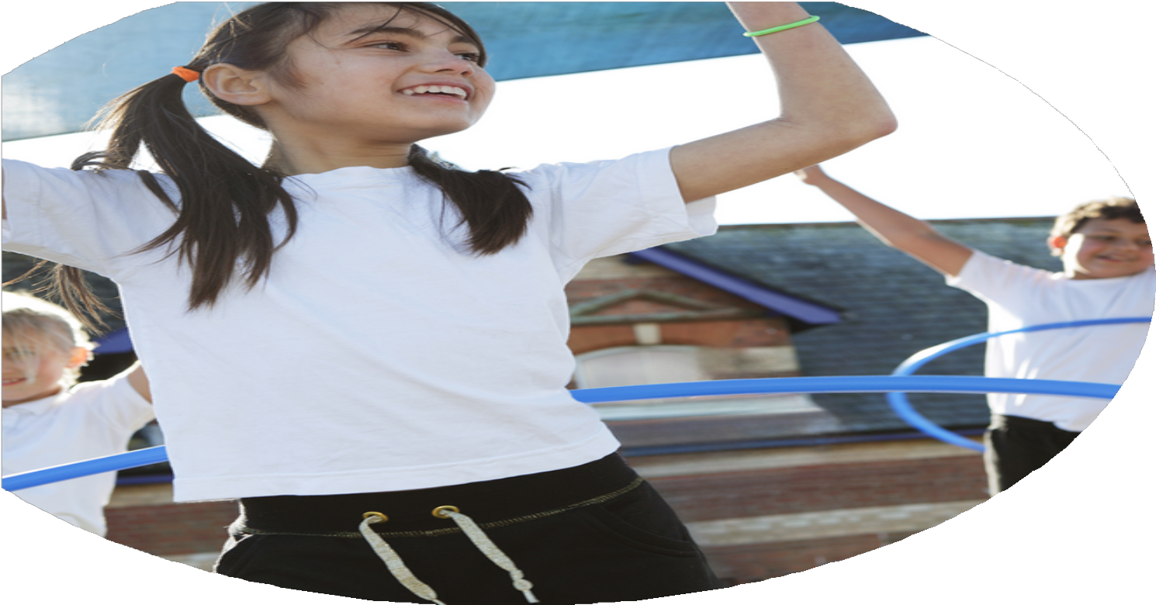
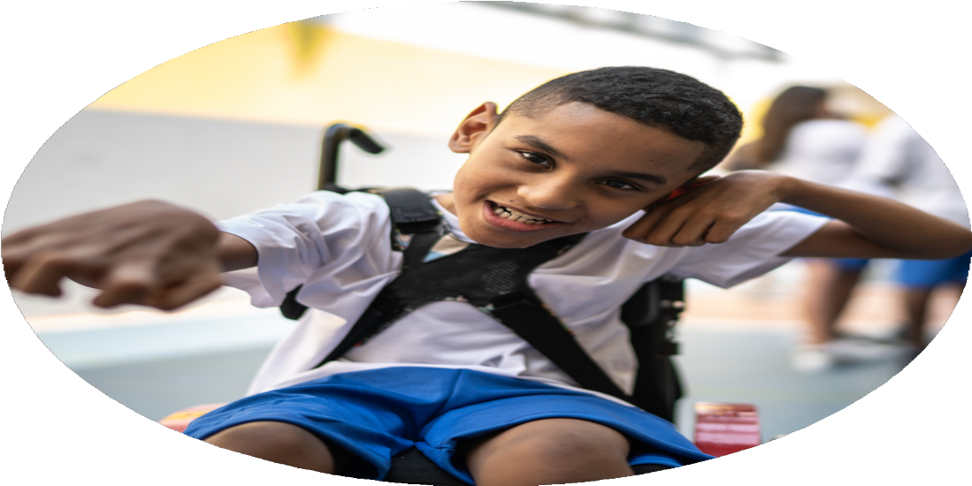




PE Funding

Evaluation Form

Commissioned by

Created by

Images courtesy of Youth Sport Trust

PE Funding Evaluation Form

It is intended that this template should be used as preparation for the completion of the statutory digital reporting tool being introduced this academic year. You can upload data (including swimming) from this template onto this platform once it becomes accessible.
Before you decide how you are going to use the funding for this academic year you should reflect and evaluate the impact of your use of the funding in 2023/24.
All spending of the funding must conform with the terms outlined in the Conditions of Grant document. The template is a working document that you can amend/update during the year.
Based on your evaluation of last year’s funding you should decide what you intend to do this academic year, how you will do it, and what impact you expect it to have.

It is important that the funding is used effectively and based on your school’s needs.
You must use the funding to make additional and sustainable improvements to the PE and sport in your school. You must develop and add to the PESSPA activities that your school already offers.

Summative digital reporting from June 2025 will continue to include swimming and water safety information therefore funding can be used to provide top-up lessons where necessary to ensure pupils meet national curriculum swimming requirements.

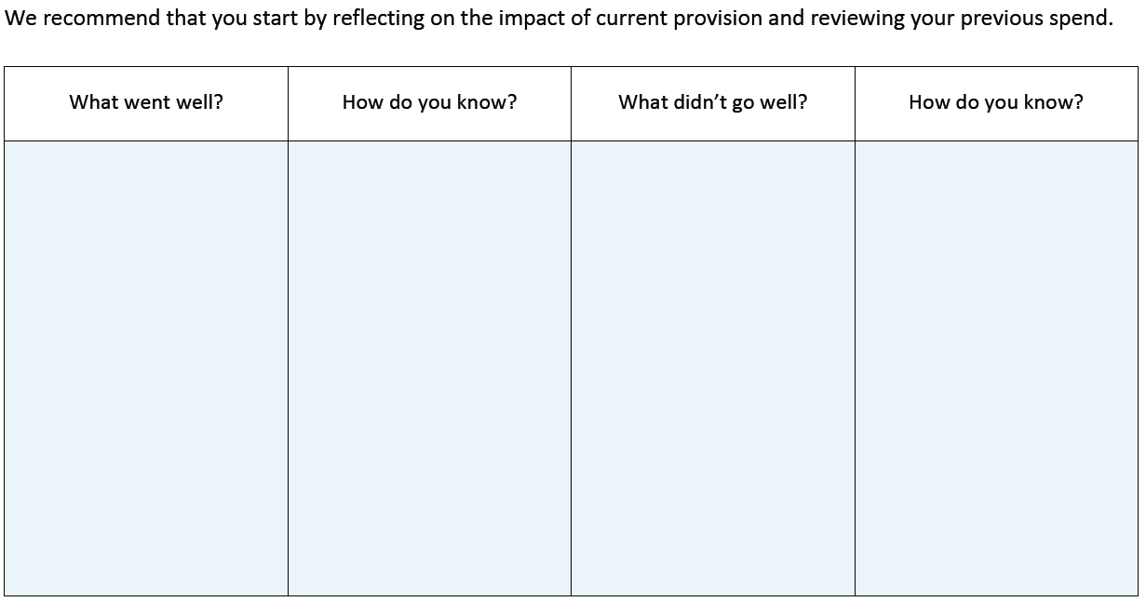

Lunchtime sports clubs

Increase in local sports competitions and increasing the profile of sport

Being part of West Berkshire School Sport Network

Lunchtime sports clubs had a large intake of pupils each week, including pupils who had shown minimal interest in the sport before. Pupils were committed to the clubs and a number of pupils then joined sports clubs outside of school to further their development in the sport.

Pupils were excited to go to sports competitions and came to lunchtime clubs/after school clubs to help improve the skills needed for those competitions. A large percentage of pupils across KS2 took part in at least one sports competition throughout the year.

Links made with other schools to arrange friendly matches as well as increase in sport competition opportunities. PE lead was given the opportunity to attend CPD to further develop their skills.

What are your plans for 2024/25?

Intent
How are you going to action and achieve these plans?

Implementation
Attend local sports competitions as well as host intra school competitions which are run and supported by Year 6 pupils. Invite children to express their interest towards which sport competitions they might like to take part in.

Purchase new footballs and netballs, as well as a spring board for gymnastics.

Provide specialist sports coaches where staff members are not confident to run a club for the chosen sport. Staff with confidence and skills in a specific sport to lead a club.

Year 6 children to be given the opportunity to become play leaders and run lunchtime clubs. Sports lead to listen to new ideas from the Year 6 children as to how the profile of sport can be raised within school.
Aim for every child to take part in an inter/intra school sports competition at least once throughout the year.

Ensure we have the correct and suitable sports equipment to support our PE curriculum.

Continue to run lunchtime and after-school sports clubs which align with sports being covered in the curriculum as well as sports which are not explicitly taught within our curriculum.

Encourage more leadership and engagement from Year 6 pupils to help raise the profile of sport in school.

What impact/intended impact/sustainability are you
expecting?
How will you know? What evidence do you have or
expect to have?
A record will be kept to show which children took part in intra and inter school competitions.

Pupil voice surveys at the end of the year to see what sports they have taken part in throughout the year and whether they have enjoyed them.

A record will be kept of pupils attending lunchtime and after-school clubs as well as taking part in inter and intra competitions.

Records taken of the number of lunchtime activities run by Year 6 pupils and who is running the activities.
A large percentage of children across the school to attend inter-school competitions as well as 95% of pupils across the school to take part in intra-school competitions.

Teachers will have the correct equipment for their PE lessons meaning pupils can effectively take part in the lesson and learning goals can be achieved. New and exciting equipment can also motivate the children as they may not have used some of it before. Pupils will experience a wider range of sports because they have access to the correct equipment.

More pupils meeting their daily physical activity goal, more pupils encouraged to take part in sports activities. More girls engaged in sport.

Pupils develop their leadership skills whilst also encouraging more pupils to take part in sports activities. Pupils achievements both inside and outside of school are celebrated, giving them positive experiences linked to sports.

What impact/sustainability have you seen?
What evidence do you have?
In the survey at the beginning of the year only a small number of children (2/3) did not have a single sporting event which they were interested in taking part in. During our Winter House Sports all of Year 5 and 6 took part in either Rugby or Hockey matches, only 4 Year 3 and 4 children chose not to take part in either Rugby or Hockey matches.

Judo – 27 chln 25b/2g
Netball – 13 chln 3b/10g
Tag rugby – 13chln 11b/2g
KS1 football – 15chln 11b/4g
Increased interest towards attending sports competitions (inter and intra)

Large intake for sports clubs (lunchtime and after school) with a mixture of genders attending

A number of Year 6 children have been offering lunchtime sports activities.

Children frequently inform us of recent sporting achievements outside of school and these are celebrated every week.

